**A Compact Deep Learning Model for Robust Facial Emotion Recognition with Anaconda Python Keras and Pandas packages**

Vishnu.V

Department of Computer Applications

Akhil Mathew Philip

Assistant Professor

Saintgits College of Engineering

Pathamuttom, Kottayam Kerala.

India-688561

Vishnuvnair0024@gmail.com

Department of Computer Applications

Saintgits College of Engineering

Pathamuttom Kottayam Kerala.

India-688561

**ABSTRACT**

In this paper I propose a compact CNN model for facial expression recognition. Expression recognition on the low quality image database is more challenging because it contains more low-intensity expressions which are difficult to distinguish with insufficient image resolution. Data collection for facial expression recognition is expensive and time-consuming. Research indicates that using images downloaded from the Internet is helpful to model training for the expression recognition problem. To this end, we extra datasets to improve the training of facial expression recognition, each representing specific data source. Moreover, to prevent subjective annotation, each dataset we collected is labeled with different approaches to ensure the annotation qualities.

Recognizing precise expression from a variety of expression forms of different people would be a huge problem. To solve this problem, this project generates an **Emotion Detection Model** to extract emotion from image input.

This work mainly focuses on psychological approach of **c**olor circle-emotion relation to find the accurate emotion behind the video frame input image (image input). At first the whole image will be image preprocessed and pixel by pixel data studied. And the combinations of these circles based on combined data will result into a new color. This resulted color will be directly linked to a particular emotion. Based on psychological theories output will be of reasonable

Accuracy. The major application of this work would be to predict a person’s emotion based on his face images, video frames etc. This can even be applied for evaluating the public option relating to a particular movie form the video reaction posts on social Medias.

Facial expression is one of the most powerful, natural and universal signals for human beings to convey their emotional states and intentions. The frame-to-sequence approach successfully exploits temporal information and it improves the accuracies on the public benchmarking databases. Prototypical facial expressions are anger, disgust, fear, happiness, sadness, and surprise. Contempt was subsequently added as one of the basic emotions. Having sufficient labeled training data that include as many variations of the populations and environments as possible is important for the design of a deep expression recognition system.

Behaviors, actions, poses, facial expressions and speech; these are considered as channels that convey human emotions. Extensive research has being carried out to explore the relationships between these channels and emotions. This paper proposes a prototype system which automatically recognizes the emotion represented on a face. Thus a neural network based solution combined with image processing is used in classifying the universal emotions: Happiness, Sadness, Anger, Disgust, Surprise and Fear. Colored frontal face images are given as input to the prototype system.

After the face is detected, image processing based feature point extraction method is used to extract a set of selected feature points. Finally, a set of values obtained after processing those extracted feature points are given as input to the neural network to recognize the emotion contained *.*The three main steps that are common in automatic deep FER, i.e., pre-processing, deep feature learning and deep feature classification.

**Keywords**

Image processing, facial expression, Deep learning,pythonprogramming,OpenCV,Numpy,Scipy,Theano,Tenserflow,Seaborn and finally ultimate Keras and Pandas packages.

1. **INTRODUCTION**

What is emotion? **Emotion** is a mental state variously associated with thoughts, feelings, behavioral responses, and a degree of [pleasure](https://en.wikipedia.org/wiki/Pleasure) or [displeasure](https://en.wikipedia.org/wiki/Suffering). There is currently no scientific [consensus](https://en.wikipedia.org/wiki/Consensus) on a definition. Emotion is often [intertwined](https://en.wikipedia.org/wiki/Reciprocal_influence) with [mood](https://en.wikipedia.org/wiki/Mood_(psychology)), [temperament](https://en.wikipedia.org/wiki/Temperament), [personality](https://en.wikipedia.org/wiki/Personality_psychology), [disposition](https://en.wikipedia.org/wiki/Disposition), and [motivation](https://en.wikipedia.org/wiki/Motivation).

Research on emotion has increased significantly over the past two decades with many fields contributing including [psychology](https://en.wikipedia.org/wiki/Psychology), [neuroscience](https://en.wikipedia.org/wiki/Neuroscience), [endocrinology](https://en.wikipedia.org/wiki/Endocrinology), [medicine](https://en.wikipedia.org/wiki/Medicine), [history](https://en.wikipedia.org/wiki/History), [sociology of emotions](https://en.wikipedia.org/wiki/Sociology_of_emotions), and [computer science](https://en.wikipedia.org/wiki/Computer_science). The numerous theories that attempt to explain the origin, neurobiology, experience, and [function](https://en.wikipedia.org/wiki/Functional_accounts_of_emotion) of emotions have only fostered more intense research on this topic. Current areas of research in the concept of emotion include the development of materials that stimulate and elicit emotion. In addition [PET scans](https://en.wikipedia.org/wiki/PET_scans) and [fMRI](https://en.wikipedia.org/wiki/FMRI) scans help study the [affective picture](https://en.wikipedia.org/wiki/International_Affective_Picture_System) processes in the brain.

"Emotions can be defined as a positive or negative experience that is associated with a particular pattern of physiological activity." Emotions produce different physiological, behavioral and cognitive changes. The original role of emotions was to motivate adaptive behaviors that in the past would have contributed to the passing on of genes through survival, reproduction, and kin selection.

In some theories, [cognition](https://en.wikipedia.org/wiki/Cognition) is an important aspect of emotion. Those acting primarily on the emotions they are feeling may seem as if they are not thinking, but mental processes are still essential, particularly in the interpretation of events. For example, the realization of our believing that we are in a dangerous situation and the subsequent arousal of our body's nervous system (rapid heartbeat and breathing, sweating, muscle tension) is integral to the experience of our feeling afraid. Other theories, however, claim that emotion is separate from and can precede cognition. Consciously experiencing an emotion is exhibiting a mental representation of that emotion from a past or hypothetical experience, which is linked back to a content state of pleasure or displeasure. The content states are established by verbal explanations of experiences, describing an internal state.

Emotions are complex. According to some theories, they are states of feeling that result in physical and psychological changes that influence our behavior. The [physiology](https://en.wikipedia.org/wiki/Physiology) of emotion is closely linked to [arousal](https://en.wikipedia.org/wiki/Arousal) of the [nervous system](https://en.wikipedia.org/wiki/Nervous_system) with various states and strengths of arousal relating, apparently, to particular emotions. Emotion is also linked to behavioral tendency. Extroverted people are more likely to be social and express their emotions, while introverted people are more likely to be more socially withdrawn and conceal their emotions. Emotion is often the driving force behind [motivation](https://en.wikipedia.org/wiki/Motivation), positive or negative. According to other theories, emotions are not causal forces but simply syndromes of components, which might include motivation, feeling, behavior, and physiological changes, but no one of these components is the emotion. Nor is the emotion an entity that causes these components.

Emotions involve different components, such as subjective experience, [cognitive processes](https://en.wikipedia.org/wiki/Cognitive_process), expressive behavior, psychophysiological changes, and instrumental behavior. At one time, academics attempted to identify the emotion with one of the components: [William James](https://en.wikipedia.org/wiki/William_James) with a subjective experience, [behaviorists](https://en.wikipedia.org/wiki/Behaviorist) with instrumental behavior, physiologist with physiological changes, and so on. More recently, emotion is said to consist of all the components. The different components of emotion are categorized somewhat differently depending on the academic discipline. In [psychology](https://en.wikipedia.org/wiki/Psychology) and [philosophy](https://en.wikipedia.org/wiki/Philosophy), emotion typically includes a [subjective](https://en.wikipedia.org/wiki/Subjectivity), [conscious](https://en.wikipedia.org/wiki/Conscious) [experience](https://en.wikipedia.org/wiki/Subjective_experience) characterized primarily by [psychophysiological](https://en.wikipedia.org/wiki/Psychophysiology) [expressions](https://en.wikipedia.org/wiki/Emotional_expression), [biological reactions](https://en.wikipedia.org/wiki/Metabolism), and [mental states](https://en.wikipedia.org/wiki/Mental_state). A similar multi componential description of emotion is found in [sociology](https://en.wikipedia.org/wiki/Sociology). For example, Peggy Theistdescribed emotions as involving physiological components, cultural or emotional labels (anger, surprise, etc.), expressive body actions, and the appraisal of situations and contexts.

**What is Artificial intelligence (AI)?** Artificial Intelligence (AI) is the field of computer science dedicated to solving cognitive problems commonly associated with human intelligence, such as learning, problem solving, and pattern recognition. Artificial Intelligence, often abbreviated as "AI", may connote robotics or futuristic scenes, AI go well beyond the automatons of science fiction, into the non-fiction of modern day advanced computer science. Professor Pedro Domingo’s, a prominent researcher in this field, describes “five tribes” of machine learning, comprised of symbolists, with origins in logic and philosophy; connectionists, stemming from neuroscience; revolutionaries’, relating to evolutionary biology; Bayesians, engaged with statistics and probability; and analogizes with origins in psychology. Recently, advances in the efficiency of statistical computation have led to Bayesians being successful at furthering the field in a number of areas, under the name “machine learning”. Similarly, advances in network computation have led to connectionists furthering a subfield under the name “deep learning”. Machine learning (ML) and deep learning (DL) are both computer science fields derived from the discipline of Artificial Intelligence.

Artificial intelligence (AI) makes it possible for machines to learn from experience, adjust to new inputs and perform human-like tasks. Most AI examples that we hear about today – from chess-playing computers to self-driving cars – rely heavily on deep learning and natural language processing. Using these technologies, computers can be trained to accomplish specific tasks by processing large amounts of data and recognizing patterns in the data.

**What is Deep learning**? Deep learning is a machine learning technique that teaches computers to do what comes naturally to humans: learn by example. Deep learning is a key technology behind driverless cars, enabling them to recognize a stop sign, or to distinguish a pedestrian from a lamppost. It is the key to voice control in consumer devices like phones, tablets, TVs, and hands-free speakers. Deep learning is getting lots of attention lately and for good reason. It’s achieving results that were not possible before.

In deep learning, a computer model learns to perform classification tasks directly from images, text, or sound. Deep learning models can achieve state-of-the-art accuracy, sometimes exceeding human-level performance. Models are trained by using a large set of labeled data and neural network architectures that contain many layers.

* 1. **INTRODUCTION TO DEEP LEARNING PACKAGES**

**KERAS**: Keras is a high-level neural networks API, written in Python and capable of running on top of [Tensor Flow](https://github.com/tensorflow/tensorflow), [CNTK](https://github.com/Microsoft/cntk), or [Theano](https://github.com/Theano/Theano). It was developed with a focus on enabling fast experimentation. Being able to go from idea to result with the least possible delay is key to doing good research.

Use Keras if you need a deep learning library that:

* Allows for easy and fast prototyping (through user friendliness, modularity, and extensibility).
* Supports convolutional networks and recurrent networks, as well as combinations of the two.
* Runs seamlessly on CPU and GPU.

Keras is an API designed for human beings, not machines. It puts user experience front and center. Keras follows best practices for reducing cognitive load: it offers consistent & simple APIs, it minimizes the number of user actions required for common use cases, and it provides clear and actionable feedback upon user error.

**PANDAS**: pandas are an open source, BSD-licensed library providing high-performance, easy-to-use data structures and data analysis tools for the [Python](https://www.python.org/) programming language.

Pandas are a [NumFOCUS](https://www.numfocus.org/open-source-projects.html) sponsored project. This will help ensure the success of development of pandas as a world-class open-source project, and makes it possible to [donate](https://pandas.pydata.org/donate.html) to the project.

The rest of this paper is as follows. Section 2 is devoted for the related work of the area while Section 3 provides proposed frame works Section 4 provides Dataset collection Section 5 deals with parameterized efficiency limitations Section 6 deals with experiment on dataset Section 7 result Section 8 results and finally Section 9 reference.

**2.0 RELATED WORK**

The recent work relevant to the study can be broadly categorized in to three: Face detection, Facial feature extraction and Emotion classification. The number of research carried out in each of these categories is quite sizeable and noteworthy.

**3.0 PROPOSED FRAMEWORK**

The overall pipeline of the proposed deep learning approach is depicted in Figure 1.0. My frame work approach consists of three modules: Data Analysis, Training the data and Data identification. To ensure my framework could be extended to different scenarios, I do not adopt any temporal normalization method.

**3.1 PROCESSING**

For my project work, first of all I have collected the required dataset which is stored in my system. There are two type of datasets one is for training and other is for testing; each image in the test dataset is processed by convolutional neural network (CNN) in the order of matrix generation, it may be (1*1, 2*2, 3*3…..) the more lesser matrix I will generate will produce more accurate prediction, it may also consume much time to train, if we assign larger matrix, the accuracy of prediction will decreases. After convolution then comes the pooling process, then flattening and finally the trained dataset is stored with python H5py file.

Then the test data is also follows the same convolutional neural network (CNN) process and finally compared it with stored dataset values in H5py file, and then finally it will predict the facial emotion and accuracy value in percentage.

The more dataset I will be trained will get more accurate prediction. For the purpose of this project work I will use only basic eight facial emotions like Anger, Happy, Sad, Contempt, Disgust, surprise, fear and Neutral.

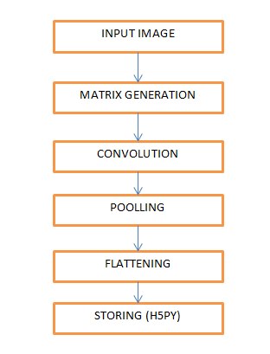

Figure 1.0 The proposed frame work for image based facial expression recognition using CNN and Deep Learning.

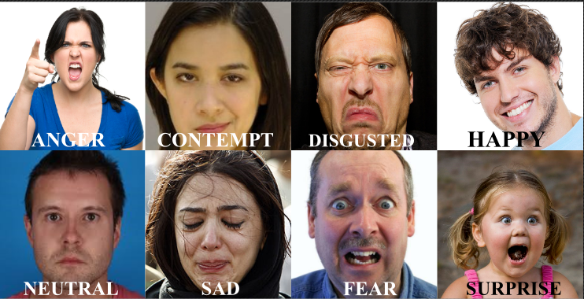

Figure 2.0 Basic eight emotions used in this project frame work.

**3.2 THE CONVOLUTIONAL NURAL NETWORK MODEL**

A specific kind of such a deep neural network is the convolutional network, which is commonly referred to as CNN or ConvNet. It's a deep, feed-forward artificial neural network. Remember that feed-forward neural networks are also called multi-layer perceptron’s (MLPs), which are the quintessential deep learning models. The models are called "feed-forward" because information flows right through the model. There are no feedback connections in which outputs of the model are fed back into itself.

CNNs specifically are inspired by the biological visual cortex. The cortex has small regions of cells that are sensitive to the specific areas of the visual field. This idea was expanded by a captivating experiment done by Hubel and Wiesel in 1962. In this experiment, the researchers showed that some individual neurons in the brain activated or fired only in the presence of edges of a particular orientation like vertical or horizontal edges. For example, some neurons fired when exposed to vertical sides and some when shown a horizontal edge. Hubel and Wiesel found that all of these neurons were well ordered in a columnar fashion and that together they were able to produce visual perception. This idea of specialized components inside of a system having specific tasks is one that machines use as well and one that you can also find back in CNNs.

Convolutional neural networks have been one of the most influential innovations in the field of computer vision. They have performed a lot better than traditional computer vision and have produced state-of-the-art results. These neural networks have proven to be successful in many different real-life case studies and applications, like:

* Image classification, object detection, segmentation, face recognition;
* Self-driving cars that leverage CNN based vision systems;
* Classification of crystal structure using a convolutional neural network.

**3.3 STEEPS IN CNN MODEL PROCESSING**

The basic CNN structure is as follows: Convolution, pooling, Flattening and finally Storage.

The Convolutional Neural Network gained popularity through its use with image data, and is currently the state of the art for detecting what an image is, or what is contained in the image. CNNs even play an integral role in tasks like automatically generating captions for images.

The basic CNN structure is as follows: Convolution - Pooling - Convolution - Pooling - Fully Connected Layer – Output (storage).

**Convolution** is the act of taking the original data, and creating feature maps from it. The 2D convolution is a fairly simple operation. I start with a kernel, which is simply a small matrix of weights. This kernel “slides” over the 2D input data, performing an element wise multiplication with the part of the input it is currently on, and then summing up the results into a single output pixel.

The kernel repeats this process for every location it slides over, converting a 2D matrix of features into yet another 2D matrix of features. The output features are essentially, the weighted sums (with the weights being the values of the kernel itself) of the input features located roughly in the same location of the output pixel on the input layer.

Whether or not an input feature falls within this “roughly same location”, gets determined directly by whether it’s in the area of the kernel that produced the output or not. This means the size of the kernel directly determines how many (or few) input features get combined in the production of a new output feature.

This is all in pretty stark contrast to a fully connected layer. I have 3×3=9 input features, and 3×3=9 output features. If this were a standard fully connected layer, you’d have a weight matrix of 9×9 =81parameters, with every output feature being the weighted sum of every single input feature. Convolutions allow us to do this transformation with only 9 parameters, with each output feature, instead of “looking at” every input feature, only getting to “look” at input features coming from roughly the same location.

Convolution is defined as:

https://cdn-images-1.medium.com/max/800/1*Tg4Eh8XvDI5M5pjA0R4RRQ.png

It is defined as the integral of the product of the two functions after one is reversed and shifted.

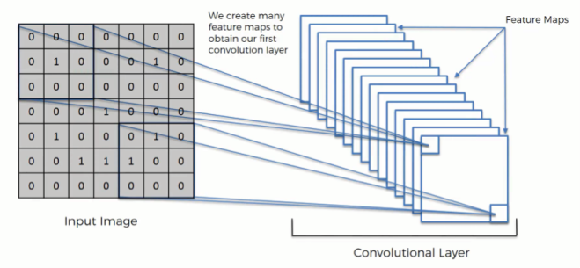

Figure 3.0 Two dimensional image convolution

**Pooling** is down-sampling, most often in the form of "max-pooling," where we select a region, and then take the maximum value in that region, and that becomes the new value for the entire region.

**The pooling layer** follows the nonlinear layer. It works with width and height of the image and performs a down sampling operation on them. As a result the image volume is reduced. This means that if some features (as for example boundaries) have already been identified in the previous convolution operation, than a detailed image is no longer needed for further processing, and it is compressed to less detailed pictures.

After completion of series of convolutional, nonlinear and pooling layers, it is necessary to attach **a** **fully connected layer**. This layer takes the output information from convolutional networks. Attaching a fully connected layer to the end of the network results in an N dimensional vector, where N is the amount of classes from which the model selects the desired class. This output is stored in python H5py file.

**3.4 MODEL TRAININNG**

For the purpose of the system I have trained my own dataset with keras and pandas packages. I have trained eight folders with different facial emotions. It has consumed more time for dataset training .To get more accuracy I have trained the dataset in 3 * 3 matrix order.

**4. DATASET COLLECTION**

At the start of this project, I found a data set from a Kaggle challenge. The data set contains 35,887 faces retrieved from Google and labeled by human labelers. However, the data set is very messy. There are tons of mislabeled, blurred faces and even anime face in it. So I chose to scrape my own data set and clean it by myself.

I ran the code 8 times for "Angry Human Face", "Happy Human Face", "Disgusted Human Face", "Fearful Human Face", "Neutral Human Face", "Sad Human Face", "Surprised Human Face", “and Contempt Human face”

Then I manually went through each picture and deleted the false ones.

After all, I ended up with: 433 "Angry Human Face", 510 "Happy Human Face", 425 Disgusted Human Face", 339 "Fearful Human Face", 369"Neutral Human Face", 436 "Sad Human Face", 469"Surprised Human Face" and 155 “Contempt Human Face”. Totally 3136 images datasets.

**4.1 DATASET TRAINING & VALIDATION.**

This project work was purely based on python 3.5 programming language .The overall purpose of this project is to predict the facial emotions of person from given images.

There are basically twenty two facial emotions are there from which we are considering only basic eight emotions as part of my work. Which are happy, sad, fear, neutral, combust, surprise, contempt and disgusted.

For this project work I used Anaconda Navigator and spider 3.3.1 as editor for python code development and execution. The packages used for this project work where numpy, scipy, mathplotlib, opencv, pandas, Keras, theano, sea born, h5py, tensor flow, python-dateutil, phtz and pyyaml. Pandas and Keras are two important packages used for this project work. Pandas are an easy-to use data structure and data analysis tools for programming language python. Which is an open secure BSD based license library. And Keras is an open source neural network library written in python. Both the packages are new and still developing and they are not stable. All other packages used here is supporting packages for both of the packages.

**TRAINING**

For the training purpose first of all I occurred a system with stable operating system, I preferred windows 10 with Intel core i7 processor and 16 GB ram for training. Then I have configured or installed Anaconda navigator package which is downloaded form their own website, with default the environment setting is root. For my own purpose I have constructed a new environment named “Facial emotion prediction” and entered to that environment and installed all the supporting packages which are necessary for my work. I then imported the training code to spider which is a python environment to execute python code. Which is already written and stored in my local disk. On that training code I have mentioned the source of the dataset which is to be trained, facial emotion detection code and necessary packages. This code may take subsequent time for execution. After successful execution the trained data set may be stored in h5py file.

Steps in CNN Processing are mentioned in paragraph 3.3.

Image matrix generation convolution

Pooling flattening h5py (storage)

**VALIDATION & CPU USAGE**

Validation process is done on my personal laptop which may have Intel i3 processor and 8 GB ram along with anaconda navigator and all the basic python packages which are required.

Trained dataset which is in the form h5py file is copied from the other system and pasted on my own personal laptop. From my laptop I have opened the frame work anaconda navigator any python editor spider 3.3.1 and loaded the validation code from my system and often executed. While Validation code executes a tkinter interface is opened automatically for selection of validation image. After selection of validation it will process same as that of dataset training ,and combined the validation data or image with trained dataset ,hence predict facial emotions or expressions.

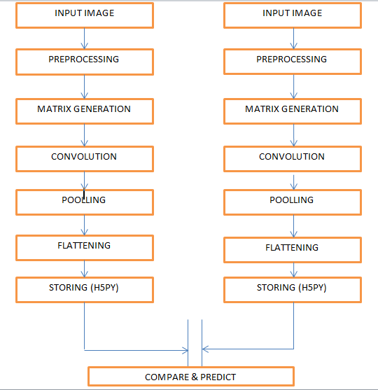

Figure 4.0 predictions of images.

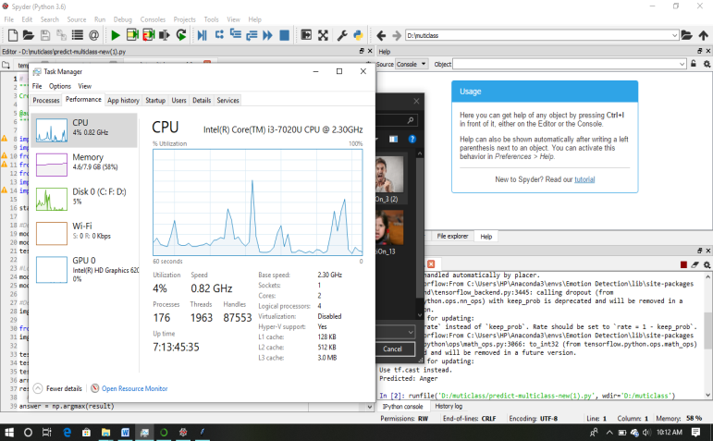

* **4.2 IMPLEMENTATION FOR REAL WORLD APPLICATIONS**
* The objective of this paper is to develop a system which can analyze the image and predict the expression of the person.
* Development of this software is more useful for police officers to predict the current emotional state of prisoners and criminals.
* This project is also useful for doctor's to predict expression of children which are affected by ***autism.***
* The major application of this work would be to predict a person’s emotion based on his face images, video frames etc. This can even be applied for evaluating the public option relating to a particular movie form the video reaction posts on social Medias.

**5. PARAMETER EFFICENCY LIMITATIONS**

For this project, limitations are:

* Low-intensity expressions which are difficult to distinguish with insufficient image resolution.
* Data collection for facial expression recognition is expensive and time-consuming.
* Recognizing precise expression from a variety of expression forms of different people would be a huge problem. To solve this problem, this project generates an **Emotion Detection Model** to extract emotion from image input.

**6.0 LEVEL ONE SET OUT EXPERIENCE**

**6.0.1** For my first experience I have test two facial emotions happy and sad with two folders having 100 images each ,and I have trained the dataset, it had taken around 30 minute train in 15 epoch ,but when I tried to an image sometimes it may predict the correct result and sometimes false. From this I came to understand that I needed to train more images with same expressions which people belong to different countries, different ages with different faces. At finally I have updated my datasets maximum up to my availability.

**6.0.2** After updating my datasets I have set out another experiment with four of my emotions dataset collections which are happy, sad, fear and neutral. Here I used the method multiclass training. First of all I have create a folder named multiclass, in that folder I have created another two sub folders named training and testing(validation).After that I have runed the code for dataset training in spider interface provided by anaconda navigator to execute python codes. The four data set images may contain around 1500 images .It had taken 67 minutes to train .After training the trained data is then stored in the format h5py in the local folder of the system.

Then prediction, identification or validation process begin, I subsequently executed the prediction code, then image selection interface is automatically opened and I have selected the images from testing folder .i have obtained 83 % accuracy result. And some images where disorderly predicted.

**6.1 EXPERIENCE ON SELF COLLECTED DATABASE**

All the basic eight facial expression are predicted correctly. And got accuracy around 86%, but still some problems are arriving due lack of less dataset. All the dataset images are downloaded from Google images.

**7.0 RESULTS**

All the basic eight facial expression are predicted correctly. And got accuracy around **86%,** but still some problems are arriving due to less number of dataset collections and different facial appearances of

People in different countries. There are some limitations to access the usability o super computer in our organization to update more datasets, so I proceed my with this much of dataset which I have collected to be trained. And also uses internet downloaded images and my personal family images which I have collected were also used for prediction purpose.

**7.1 SCREEN SHOTS**

**ANGER**



**HAPPY**

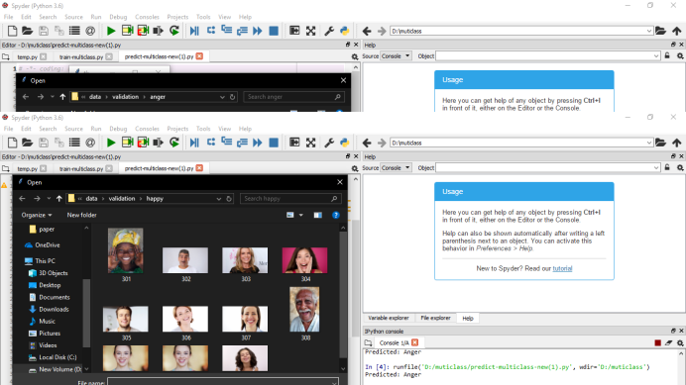

**FEAR**

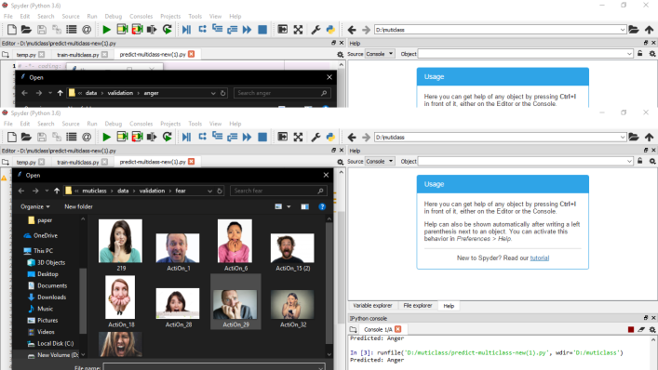

**NEUTRAL**

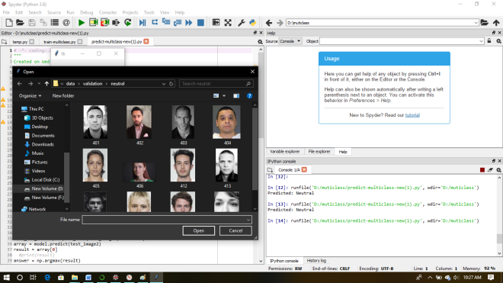

**CONTEMPT**

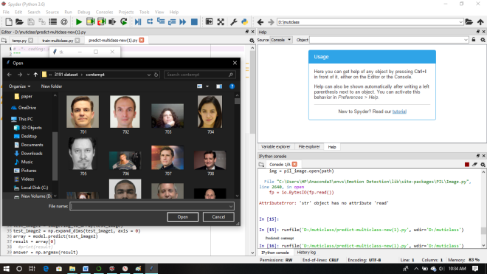

**DISGUSTED**

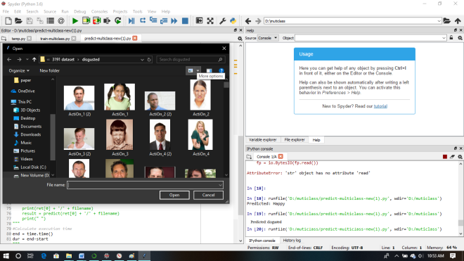

**SURPRISE**

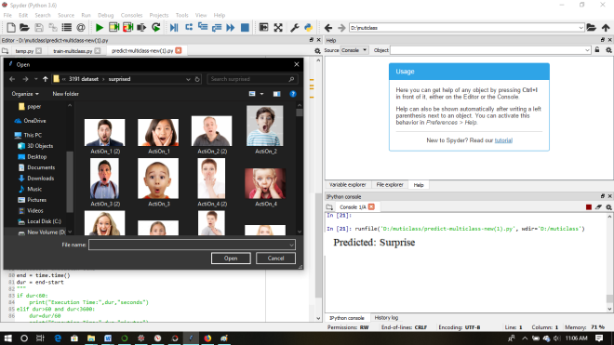

**SAD**

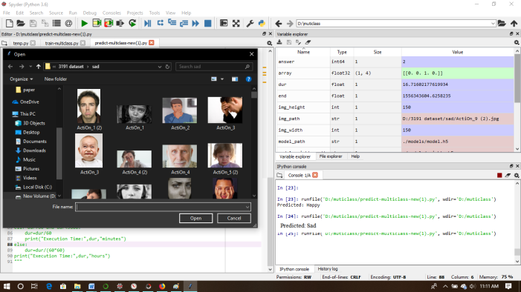

**8.0 CONCLUSION**

In this paper, I explored a novel way of classifying human emotions from facial expressions. Thus a conventional neural network based solution was proposed to classify the eight universal emotions: Happiness, Sadness, Anger, Disgust, Surprise, Fear Contempt and Neutral.

Initially two dimensional convolutions are performed to the input image, and then further step is pooling, flattening and storage of train dataset. At finally test image is compared with the value which is stored h5py file which is trained dataset, and predict the facial emotions.

The project is still continuing and is expected to produce successful outcomes in the area of emotion recognition. I expect to make the system and the Source code available for free at my github repository

**9.0 REFERENCE**

1. http://a4academics.com/interview-questions/53-database-and-sql/397-top-100-database-sql-interview-questions-and-answers-examples-queries
2. https://www.slideshare.net/SorakayalaAshok/ravi-querys-425
3. https://thiruvananthapuram.rrbonlinereg.co.in/
4. https://www.researchgate.net/publication/323471647_Emotion_Detection_using_Image_Processing_in_Python
5. https://www.thoughtworks.com/insights/blog/recognizing-human-facial-expressions-machine-learning
6. http://www.grip.unina.it/
7. https://blog.affectiva.com/the-worlds-largest-emotion-database-5.3-million-faces-and-counting
8. https://pythonprogramming.net/convolutional-neural-network-cnn-machine-learning-tutorial/https://pythonprogramming.net/convolutional-neural-network-cnn-machine-learning-tutorial/
9. https://heartbeat.fritz.ai/a-beginners-guide-to-convolutional-neural-networks-cnn-cf26c5ee17ed
10. http://cs231n.github.io/convolutional-networks/
11. https://www.frontiersin.org/people/login?returnUrl=https%3a%2f%2fwww.frontiersin.org%2fSubmission%2fSubmissionInfo.aspxhttps://nycdatascience.com/blog/student-works/facial-expression-recognition-tensorflow/
12. https://nycdatascience.com/blog/student-works/facial-expression-recognition-tensorflow/
13. https://skymind.ai/wiki/data-for-deep-learning
14. https://www.allaboutcircuits.com/technical-articles/two-dimensional-convolution-in-image-processing/
15. <https://pythonprogramming.net/convolutional-neural-network-cnn-machine-learning-tutorial/>
16. C.-C. Chang and C.-J. Lin. Libsvm: a library for support vector machines. ACM transactions on intelligent systems and technology (TIST), 2(3):27, 2011.
17. L.-F. Chen and Y.-S. Yen. Taiwanese facial expression image database. brain mapping laboratory, institute of brain
18. science, national yang-ming university, taipei, taiwan., 2007
19. [J. Chung, C. Gulcehre, K. Cho, and Y. Bengio. Empirical evaluation of gated recurrent neural networks on sequence modeling. arXiv preprint arXiv:1412.3555, 2014.
20. D. Cui, G.-B. Huang, and T. Liu. Smile detection using pairwise distance vector and extreme learning machine. In Neural Networks (IJCNN), 2016 International Joint Conferenceon, pages 2298–2305. IEEE, 2016.
21. N. Dalal and B. Triggs. Histograms of oriented gradients for human detection. In Computer Vision and Pattern Recognition,2005. CVPR 2005. IEEE Computer Society Conferenceon, volume 1, pages 886–893. IEEE, 2005.
22. Dhall et al. Collecting large, richly annotated facial expression databases from movies. 2012.
23. [7] A. Dhall, R. Goecke, J. Joshi, M. Wagner, and T. Gedeon.Emotion recognition in the wild challenge 2013. In Proceedings of the 15th ACM on International conference on multimodal interaction, pages 509–516. ACM, 2013.
24. Fabian Benitez-Quiroz, R. Srinivasan, and A. M. Martinez.Emotionet: An accurate, real-time algorithm for the automatic annotation of a million facial expressions in the wild. In Proceedings of the IEEE Conference on Computer Vision and Pattern Recognition, pages 5562–5570, 2016.
25. L. Fei-Fei. Imagenet: crowdsourcing, benchmarking & other cool things. In CMU VASC Seminar, 2010.
26. X. Glorot and Y. Bengio. Understanding the difficulty of training deep feedforward neural networks. In Aistats, volume 9, pages 249–256, 2010.
27. J. Goodfellow, D. Erhan, P. L. Carrier, A. Courville,
28. M. Mirza, B. Hamner, W. Cukierski, Y. Tang, D. Thaler, D.-H. Lee, et al. Challenges in representation learning: A report on three machine learning contests. In International Conference on Neural Information Processing, pages 117–124. Springer, 2013.
29. Y. Guo, G. Zhao, and M. Pietik¨ainen. Dynamic facial expression recognition using longitudinal facial expression atlases. In Computer Vision–ECCV 2012, pages 631–644. Springer,2012.
30. K. He, X. Zhang, S. Ren, and J. Sun. Deep residual learning for image recognition. arXiv preprint arXiv:1512.03385,2015.
31. G. E. Hinton, N. Srivastava, A. Krizhevsky, I. Sutskever, andR. R. Salakhutdinov. Improving neural networks by preventingco-adaptation of feature detectors. arXiv preprint arXiv:1207.0580, 2012.
32. G. Huang, Z. Liu, K. Q. Weinberger, and L. van der Maaten. Densely connected convolutional networks. arXiv preprint arXiv:1608.06993, 2016.
33. H. Jung, S. Lee, J. Yim, S. Park, and J. Kim. Joint fine-tuning in deep neural networks for facial expression recognition. In Proceedings of the IEEE International Conference on Computer Vision, pages 2983–2991, 2015.